**HR Analytics- Employee Attrition Dashboard**

This dashboard provides insightful analytics on employee attrition rates, demographics, and job satisfaction across different departments: HR, Research and Development, and Sales.

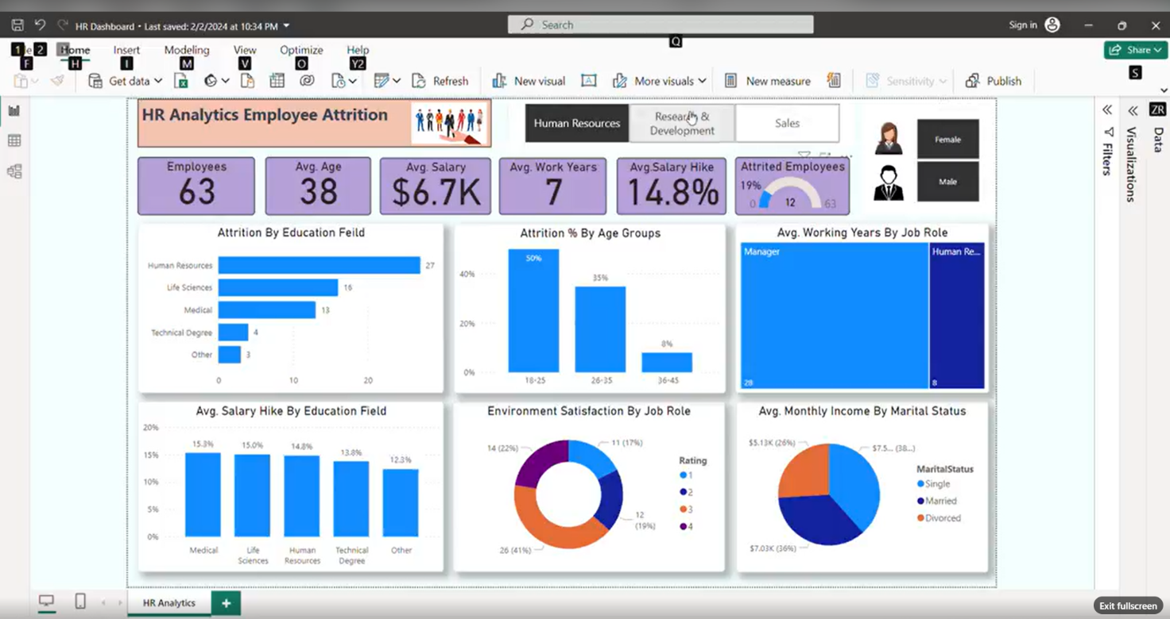

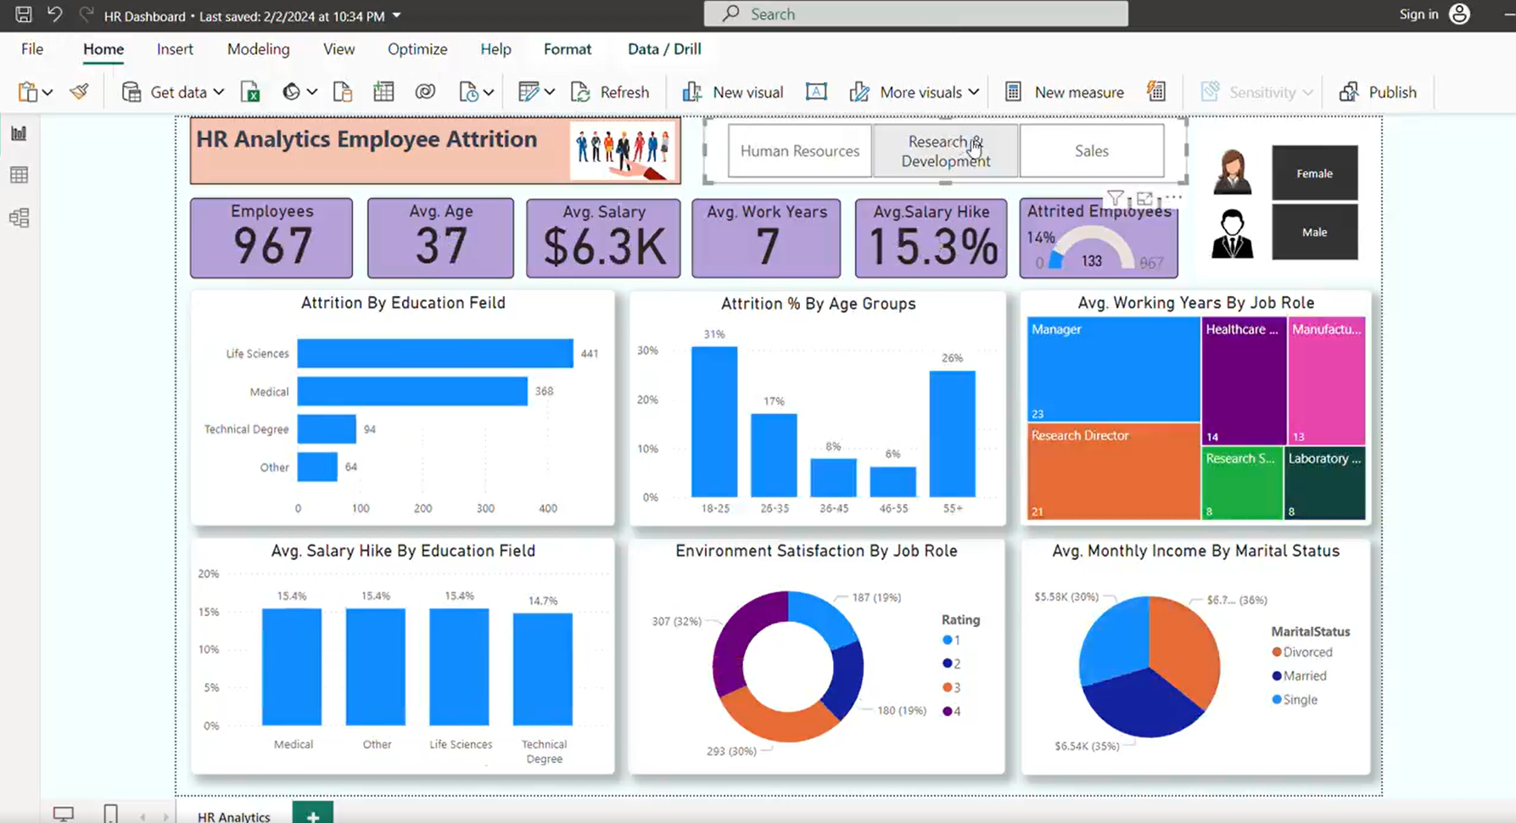

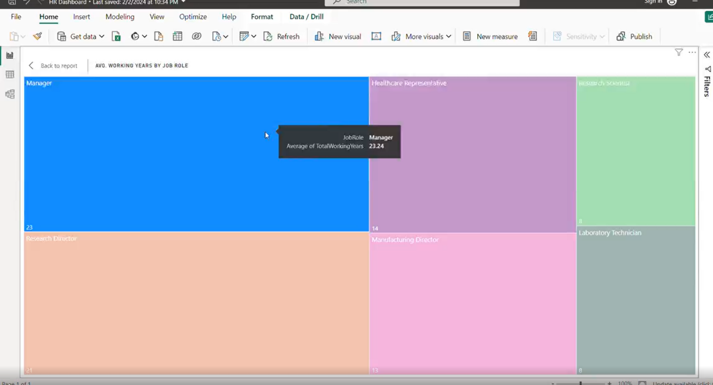

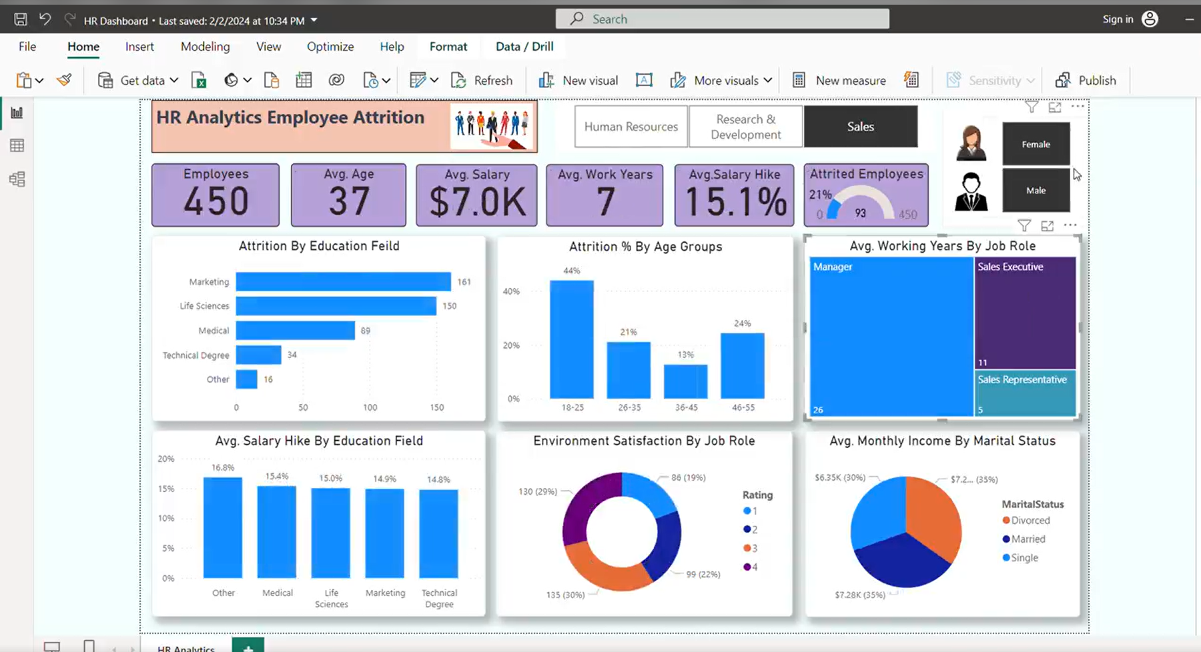

**Key of Highlight:-**

**👥For HR:**

Currently managing 63 employees with a 19% attrition rate.

Avg. employee age: 38, with a salary of $6.7K and 7 years of experience.

Attrition is highest among the 18-25 age group at 50%.

Variations in environment satisfaction and average working years based on job roles.

Interesting salary differences across marital statuses, with divorced employees earning the highest average salary.

**🔬For Research and Development:**

A workforce of 967 employees with an average age of 37 and an average salary of $6.3K.

Attrition is highest among the 18-25 age group (31%) and lowest in the 46-55 age group (6%).

Work environment satisfaction varies by job role.

Managers have the highest average work experience (23 years).

**📈For Sales:**

Employs 450 individuals with an average age of 37 and an average salary of $7,000.

Highest attrition in Life Sciences, Marketing, and medical fields.

'Other' education categories receive the highest average salary hike at 16.8%.

Overall job role satisfaction rated at level 3 out of 4.

This dashboard not only helps in understanding attrition patterns but also aids in making data-driven decisions to enhance employee retention strategies and improve job satisfaction.